R63 LED BULB
ITEM NO: VT-1862; WATTS:8W
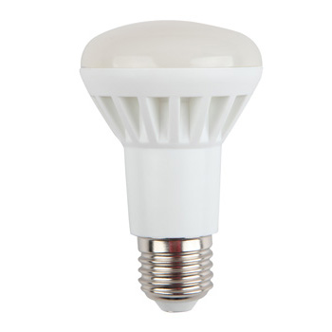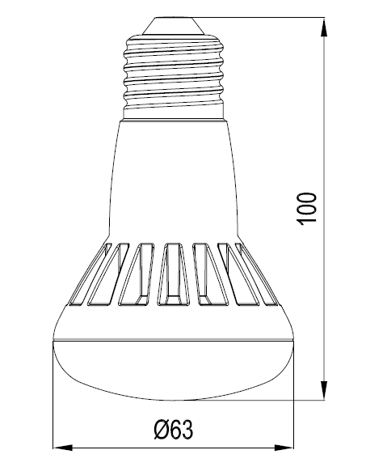
Item No: | VT-1862
SKU Codes | 4221:3000K
Type: | R63
Base | E27
Real Watts | 8W
EQ. Watts | 60W
Voltage | 170-240V,50Hz
Input Current | 63ma
Input Efficiency | 62lm/w
Lumen(lm) | 500lm
PF | >0.5
CRI | >80
Color Temperature | 3000K,4500K,6000K
Beam Angle | 120’D
LED Chip | SMD 2835
LED Qty | 16
Driver | RC Buck
Protection Class | IP20
Body Material | Plastic
Dimmable | No
Unit size | 63*100mm
Life Time | 20000hrs
Operation Temperature | -25 ~50’C
Applicable Environment | Indoor Lighting, Used in Home down light, Stairwell lighting.

Instruction Manual：
Installing please following below steps:
- Please note to cut off the power supply before replacing the lamp to prevent electric shock or lamp burning, choose to install to correspondingly lamp holders
- When try to tighten or take off the bulb, please clench radiator body by finger as shown below :

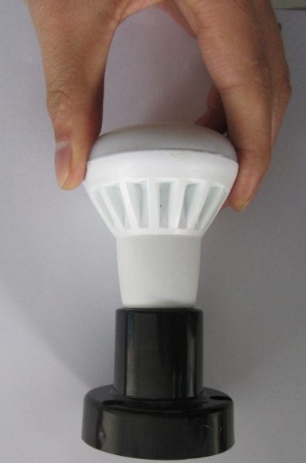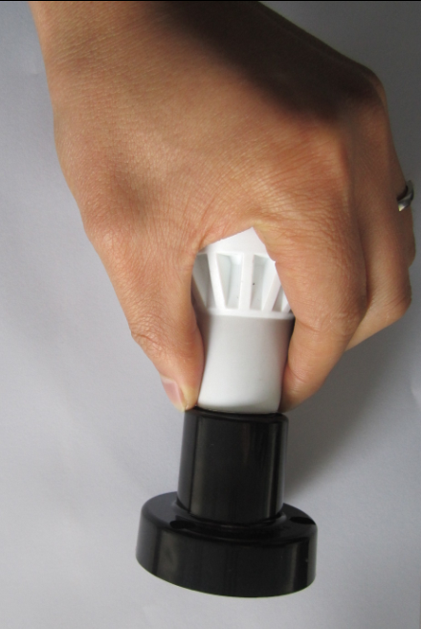

- When need to take off the bulb ,please wait 20minutes after turning off, so as not to burn your fingers

