**A60 LED BULB**

**ITEM NO: VT-1853; WATTS: 10W**

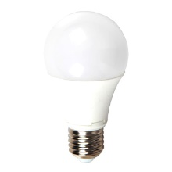

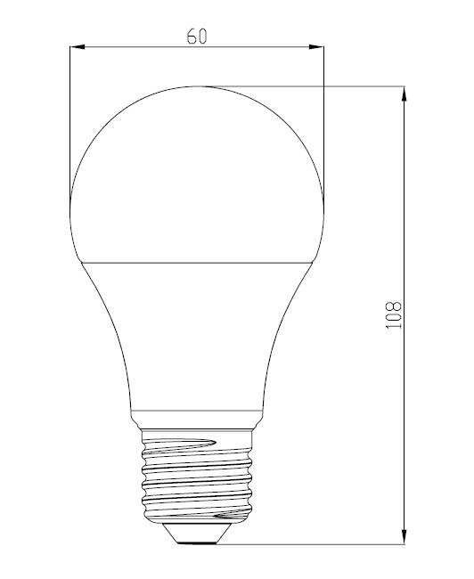

|  |  |
| --- | --- |
| Item No: | VT-1853 |
| SKU Codes | **4226:4500K** |
| Type | **A60** |
| Base | **E27** |
| Real Watts | **10W** |
| EQ. Watts | **60W** |
| Voltage | **100-240V** |
| Input Frequency | **50/60Hz** |
| Input Current | **60ma** |
| Input Efficiency | **80lm/w** |
| Lumen(lm) | **806lm** |
| PF | **>0.7** |
| CRI | **>80** |
| Color Temperature | **3000K,4500K,6000K** |
| Beam Angle | **200’D** |
| LED Chip | **SMD 2835** |
| LED Qty | **24** |
| Driver | **Non Isolated Constant Current Power** |
| Protection Class | **IP20** |
| Body Material | **Plastic** |
| Dimmable | **No** |
| Unit size | **60*108mm** |
| Life Time | **20000hrs** |
| Applicable Environment | **Indoor Lighting, Used in Home down light, Stairwell lighting.** |

**Instruction Manual：**

**Installing please following below steps:**

1. **Please note to cut off the power supply before replacing the lamp to prevent electric shock or lamp burning, choose to install to correspondingly lamp holders**
2. **When try to tighten or take off the bulb, please clench radiator body by finger as shown below :**

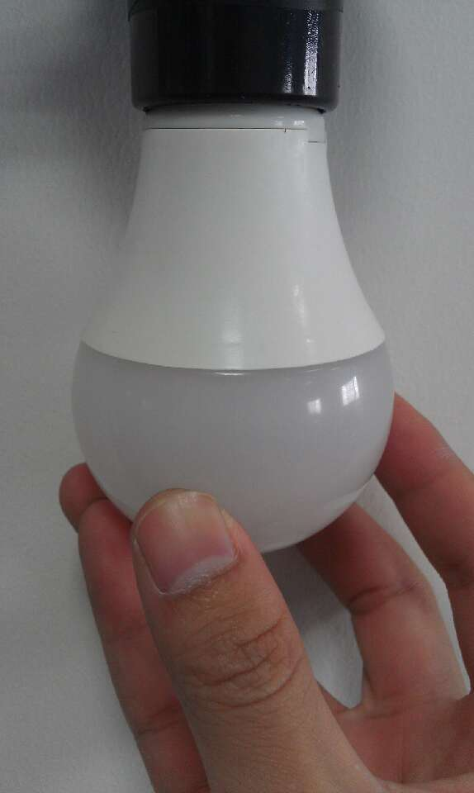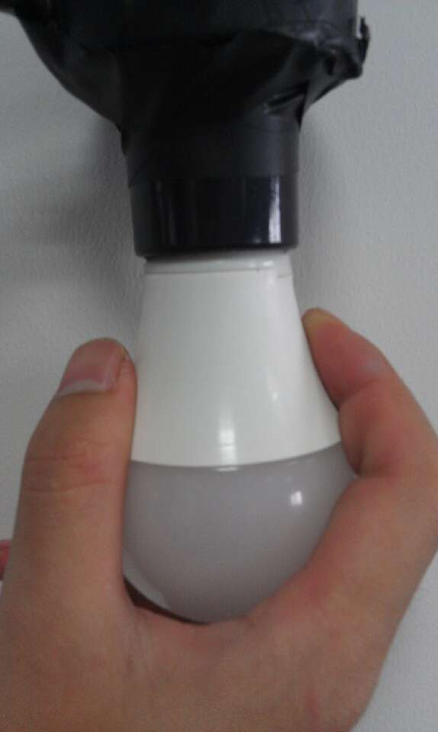

1. **When need to take off the bulb ,please wait 20minutes after turning off,so as not to burn your fingers**